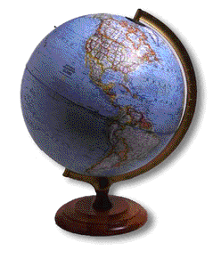
Patterns of Global Power
Culminating Activity

Drawing Boundaries

- Where to Draw the Line?
- Drawing Boundaries Instruction Sheet
- Drawing Boundaries Base Map

Where to Draw the Line? - Africa


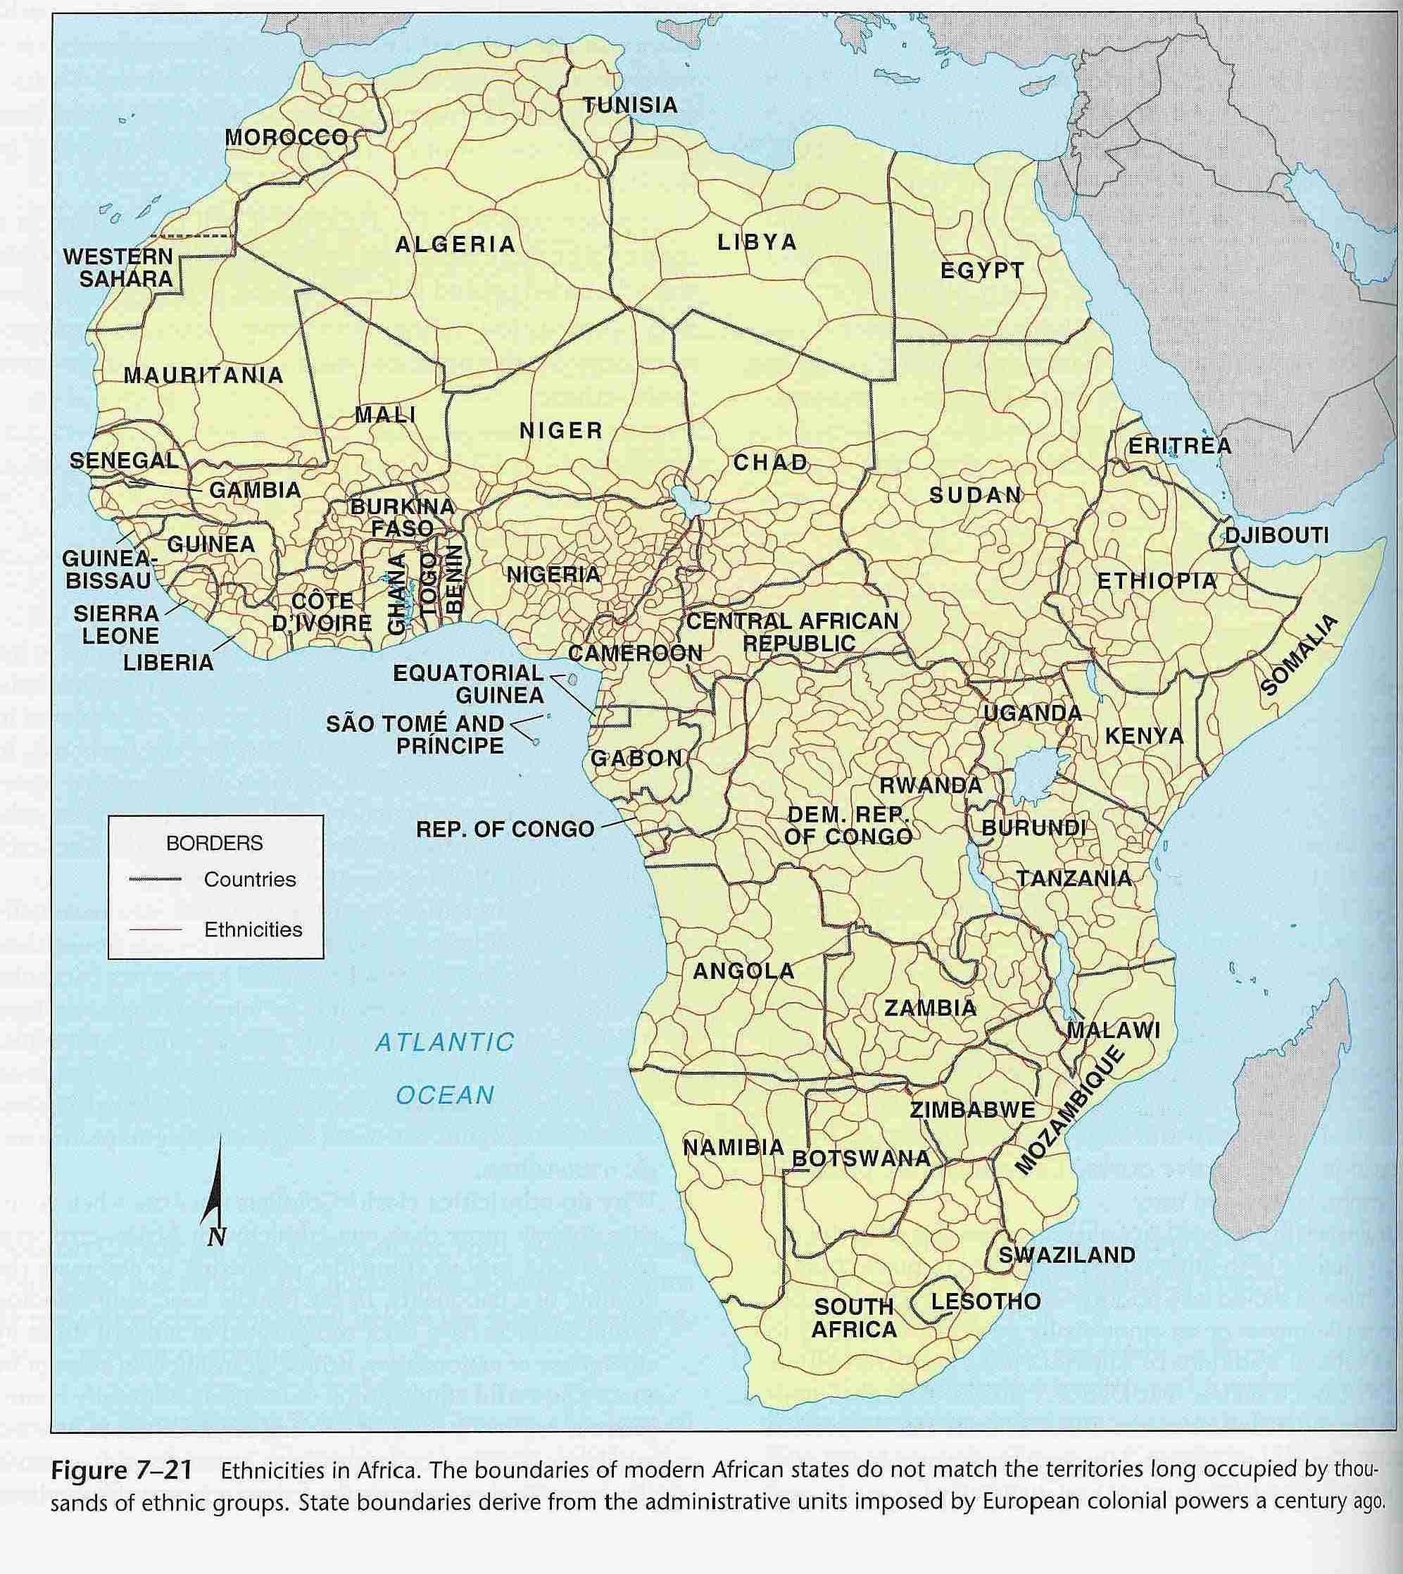
Where to Draw the Line? – The U.S. “South”

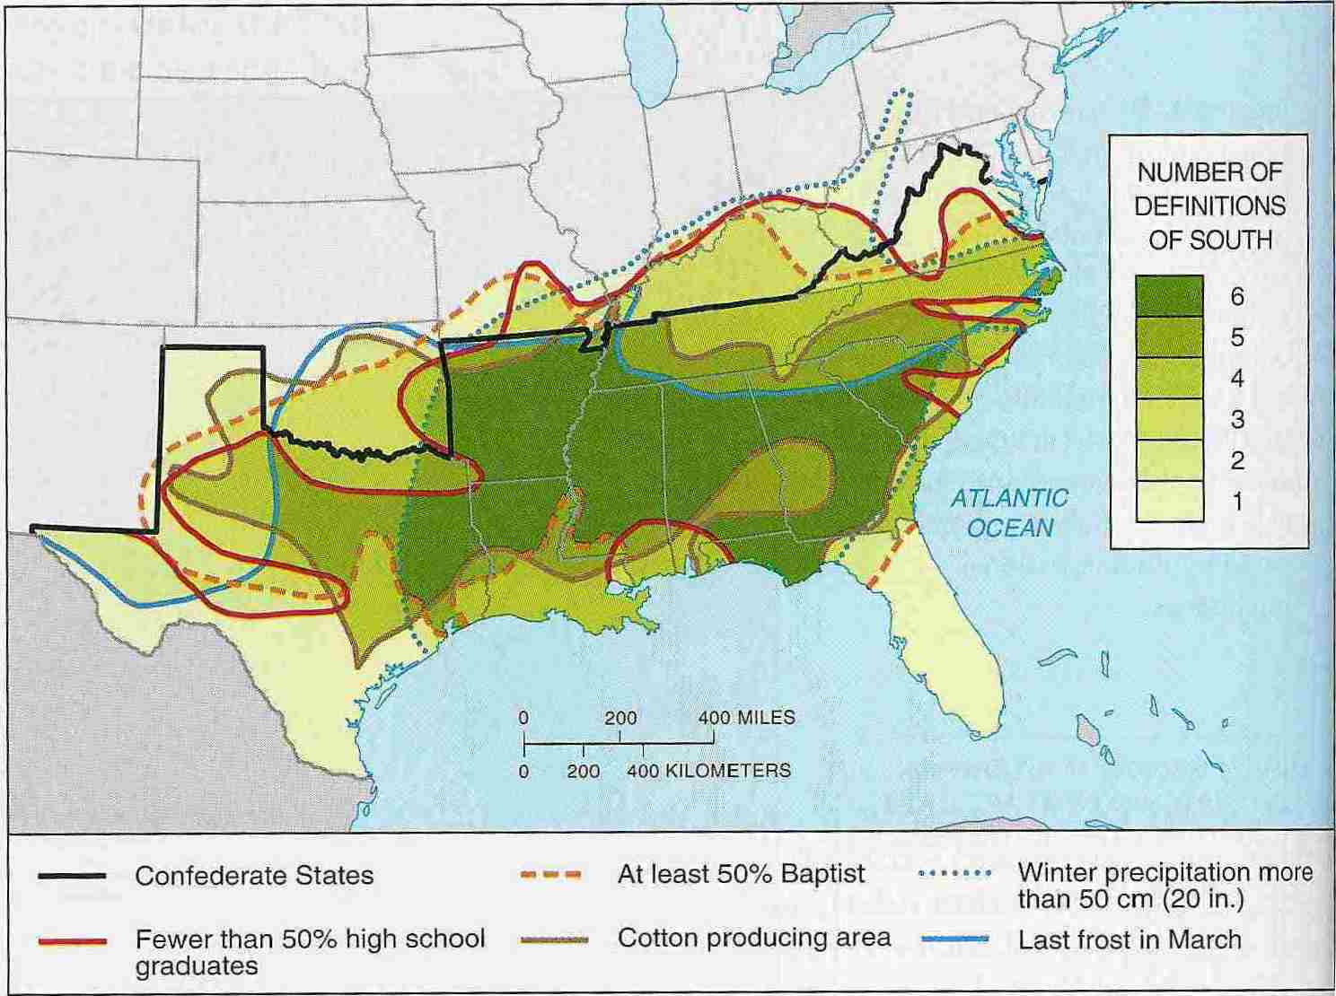
Drawing Boundaries

As a member of a specialized group of geopolitical strategists, the United Nations has commissioned you to outline where the boundary lines should be drawn for the state of Newland.

Newland – located mid-latitude on the earth, with a total population of 10 million – has recently been granted independence from a distance colonizing nation called Strassa. Due to diverse ethnic groups within Newland, the United Nations has stressed that the boundaries your team creates must minimize the chance of conflicts arising among the groups, and between Newland and its neighbours. You will make suggestions to the special envoy of the UN Secretary General who will govern Newland throughout its transition to an independent state.

You may either suggest adding district boundaries within the existing colonial boundary of Newland, or moving the colonial boundary itself in places, or both. Your team will submit a strategy proposal explaining:
- why you drew the boundary lines where you did,
- your recommendations for helping guide future United Nations intervention in Newland, and
- any other social or political initiatives you think should be introduced by the special envoy to encourage a peaceful transition in Newland.

You will also demarcate a map of Newland, showing the boundaries you describe in your strategy proposal. Use the map and the information on Newland to develop your recommendations.

Major Ethnic Groups in Newland

Neps (35% of the Population)
- The Neps were the first settlers in Newland and are the most populous group within this territory.
- They feel that the capital of independent Newland should be named after them and should be located on the Basolt River.
- They are mostly farmers and cattle raisers, but are interested in expanding their control of nearby oil and gold deposits.
- They are considering challenging the old colonial boundary with Flanland to include the Neps who reside within Flanland.

Mins (10% of the Population)
- The Mins are mostly farmers who feel that it is unjust that some of the more powerful Neps have claimed the better-quality farmland along the coastal plain.
- They are concerned about their livelihood and want to ensure that the Bins do not take over the remaining farmland.

Bins (10% of the Population)
- The Bins are also mostly farmers, but want to expand their fishing industry by securing coastal areas and the waterways between the mainland and the outer islands.
- They feel strongly that they should have full control over their land to prevent the Mins from taking over their farmland, especially on the outer islands, which contain ancient Bin burial grounds.

Mobols (10% of the Population)
- The Mobols are concentrated along the coast and are predominantly fishermen.
- They believe strongly that the outer islands of Newland should belong to them because these are valuable fishing grounds and provide the Mobols with their livelihood.
- They also want to secure waterways around the outer islands, especially to the coral reefs, in order to expand their lucrative fishing industry.

Soares (5% of the Population)
- The Soares are a sparsely populated group who live within the rainforest area.
- They are very environmentally conscious people who are trying to prevent the neighbouring state of Tropia from cutting down the shared tropical rain forests for lumber exports. The Newland Soares rely on the Tropian Soares to protest the Tropia government’s decision to allow more logging.
- They are also concerned that major flooding will occur if the Butes proceed with plans to construct hydro-electric dams along the tributaries of the Butaine River, thus destroying the habitat for hundreds of rare plant and animal species.

Butes (25% of the Population)
- The Butes are the second-largest, but most wealthy group and are spread throughout Newland.
- They will go to any lengths – including the use of military action – to secure their resource wealth (gold, oil, diamonds, and hydro-electric power).
- They strongly believe that these resources belong solely to them since they occupied the resource areas at the time of independence.

Standies (5% of the Population)
- The Standies are a small group of nomadic herders scattered throughout the interior.
- They were the first group to occupy any part of Newland and view this area to be their sacred homeland.
- They cannot afford to develop oil resources within this area, but are fearful that the more powerful Neps or Butes will take control. They are tired of being “pushed around” by the Neps and Butes and want a land agreement to protect their ancestral roots.

Neighbouring States

Flanland
- Flanland is politically stable, but is worried that the ethnic mobilization of the more powerful Neps in Newland will spread across the border. The Neps make up a significant portion of Flanland’s population and the group frequently crosses the border to move their cattle to prime grazing areas. Flanland is also worried that the Newland Neps will demand that their borders be redrawn, since these grazing lands once belong to them.

Tropia
- Tropia, also politically stable, plans to begin cutting down its rainforests for lumber exports in order to boost the economy. Since the boundary between Tropia and Newland is not clearly marked in the rainforest area, lumber companies pay little attention to where they cut down trees and take some from Newland.

Bigland
- Geographically, Bigland is large, but lacks essential resources for its population and for sustaining its economy. Bigland’s predominant group, the Biggles, are in desperate need of freshwater and are looking north to Lake Iris for help. They are also interested in the gold deposits near the Newland-Bigland border. Due to a shared cultural heritage, the Butes are inclined to help the Biggles. However, in return for resources, the Butes want the Biggles to join them in defending their claim to resources and to engage in military action if resources are threatened. The government of Bigland is concerned that an alliance with the Butes will escalate an already unstable situation in Newland. It is not comfortable with this arrangement, but feels it has no other choice if it wants to obtain crucial resources.


